Tastes from Around the World

Bavarian Inn’s Hunt Room and Patio
Wednesday, October 2, 2013
6:30 PM

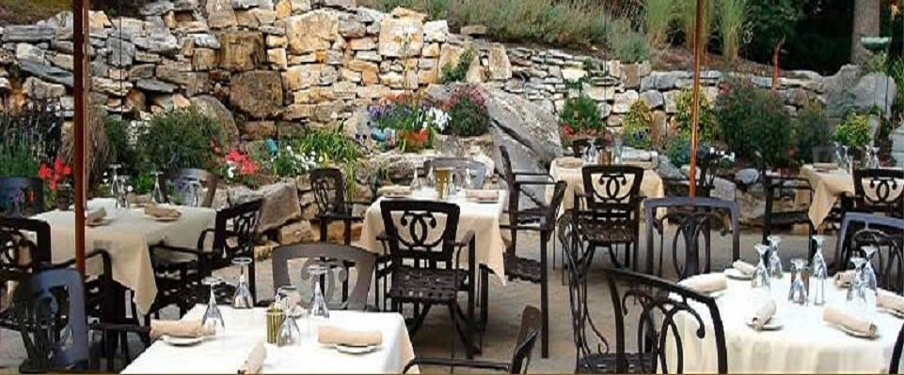

$60.00/person $120/couple
Please join us for this fabulous indoor/outdoor event featuring 4 international cuisine stations
and over 15 different complementary wines carefully selected by:

Bavarian’s Wine Expert, David Asam & Master Chef Wolfgang Vomend

RSVP today—call (304) 876-3325!

